**Project: Time Management System**

**User Manual**

**Revision:** Final

**Date:** 05/03/2020

**Author(s):** David Faulkner, Bryan Mapula, Jack Ma

|  |  |
| --- | --- |
| **NAME** | **TITLE** |
| David Faulkner | Chief User Experience Officer |
| Bryan Mapula | Chief Information Control Officer |
| Jack Ma | Chief Business Logic Officer |

|  |  |  |
| --- | --- | --- |
| **REVISION** | **DATE** | **CHANGES** |
| A | 05/03/2020 | Initial Proposal |

# Purpose

## Scope:

**Objective:** This document is meant to provide the user of TeamGrammers Application clarity on how it functions. It will explain each screens purpose, how it is used and what is required.

## Acronyms:

N/A

## Supported Web browsers:

* Chrome
* Safari
* Edge
* IE

Firefox is not currently supported and Chrome is highly recommended.

# Employee Instructions:

## Open Application

To access application, click on provided icon link 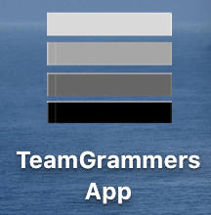. You can also click [here](https://teamgrammers.azurewebsites.net/) to access the web app. This will open your default Internet Browser, which will than open the web app home page.

## Login Screen

The following screen will load in the default web browser:

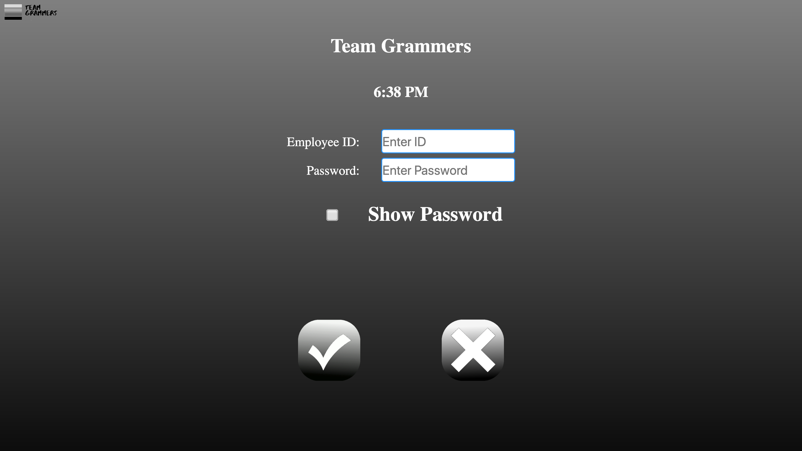

It is here that you can login using your employee credentials, simply enter your ID and password.

When you are done click the checkmark icon to submit, or the X icon to clear the form.

## Employee Welcome Screen

The following screen provides four options to the user:

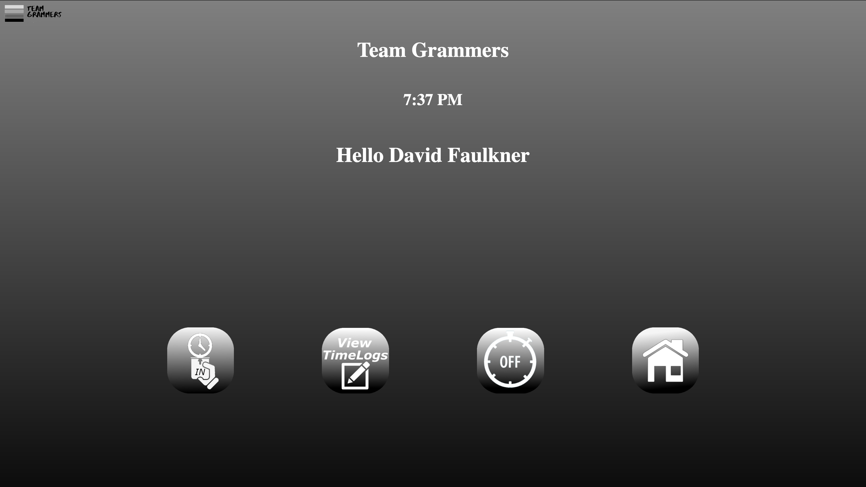

The users name should display along with the icons shown above. The first icon is the “Clock In” option. When this is selected the user is clocked into the company time clock for their shift to start. The user will then be logged out. When logged in again, the following screen will show:

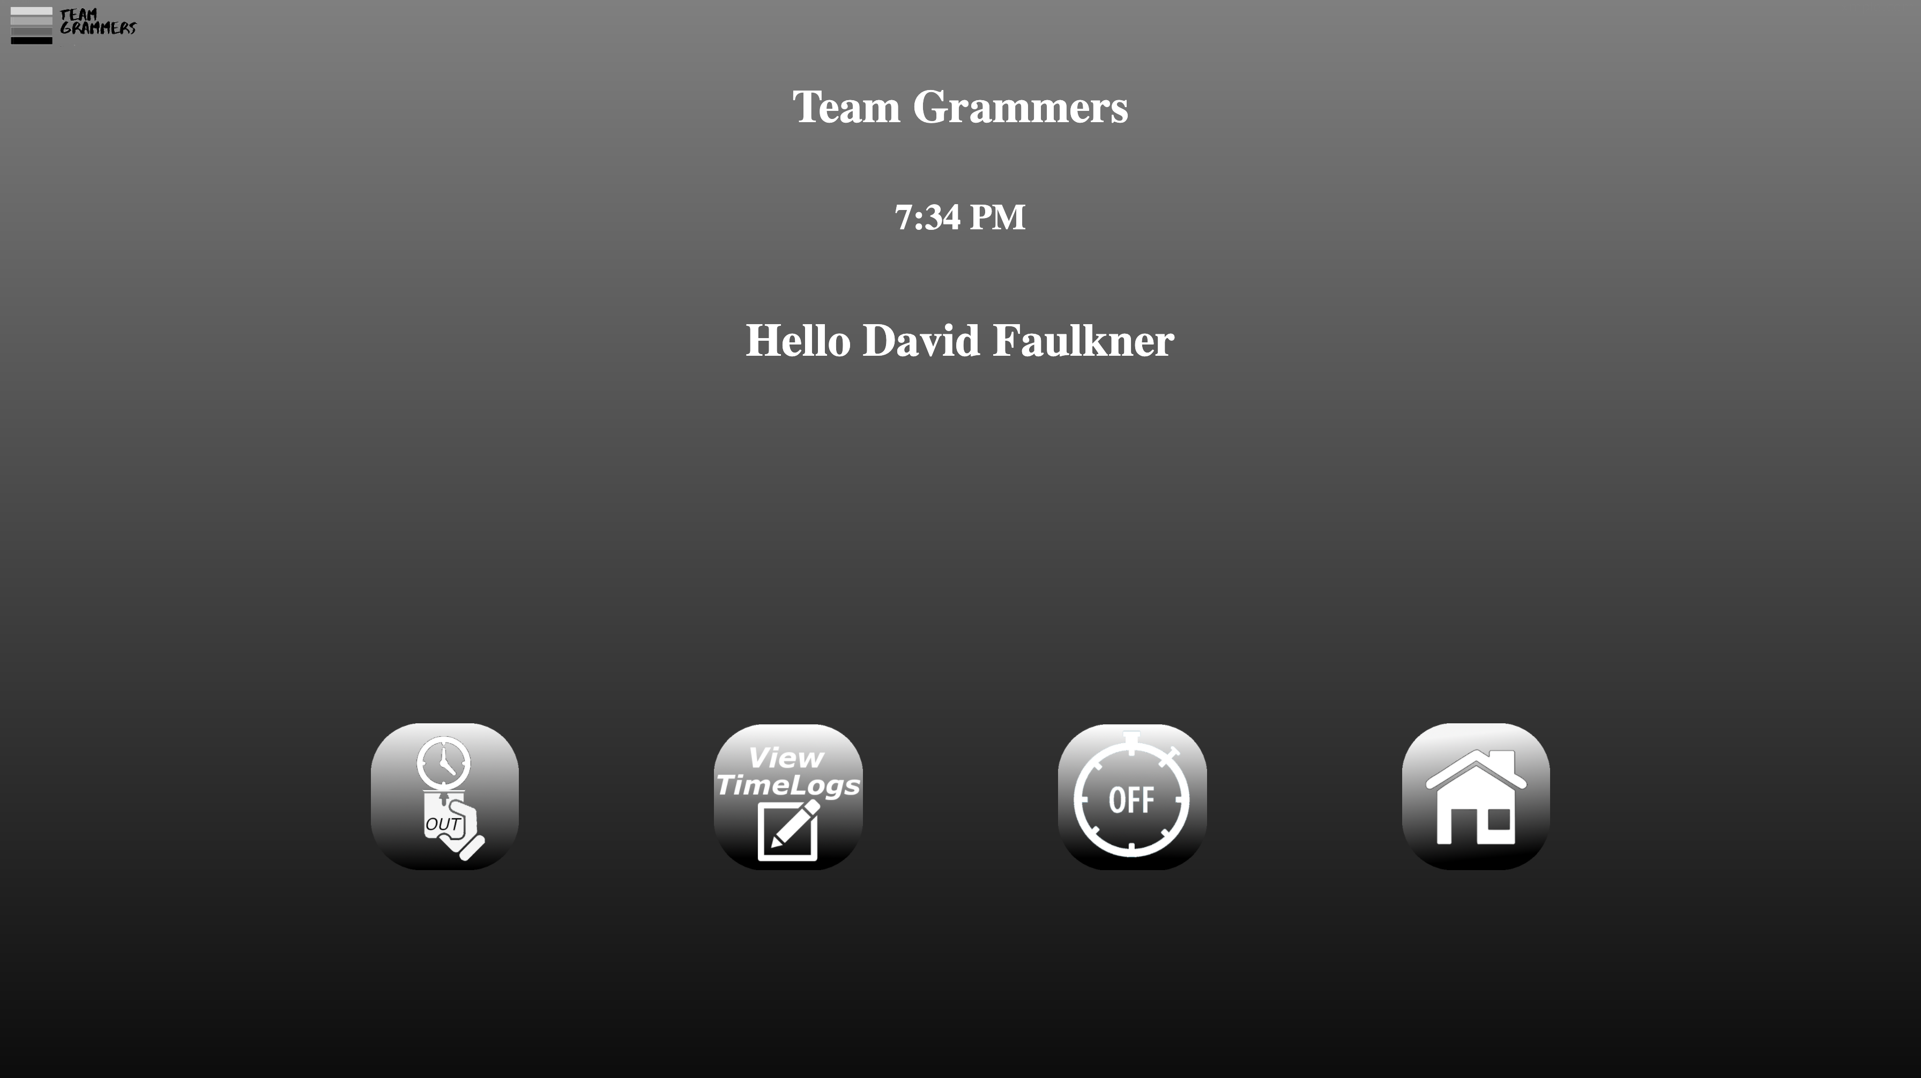

The “Clock In” icon has changed to “Clock Out”. When the user is ready to clock out of their shift this button is selected. The user will be given confirmation of clock out status followed by being logged out of the application.

## Employee Hour Logs View

To see all hours worked and submitted, click on the “View TimeLogs” icon. This brings up the following screen:

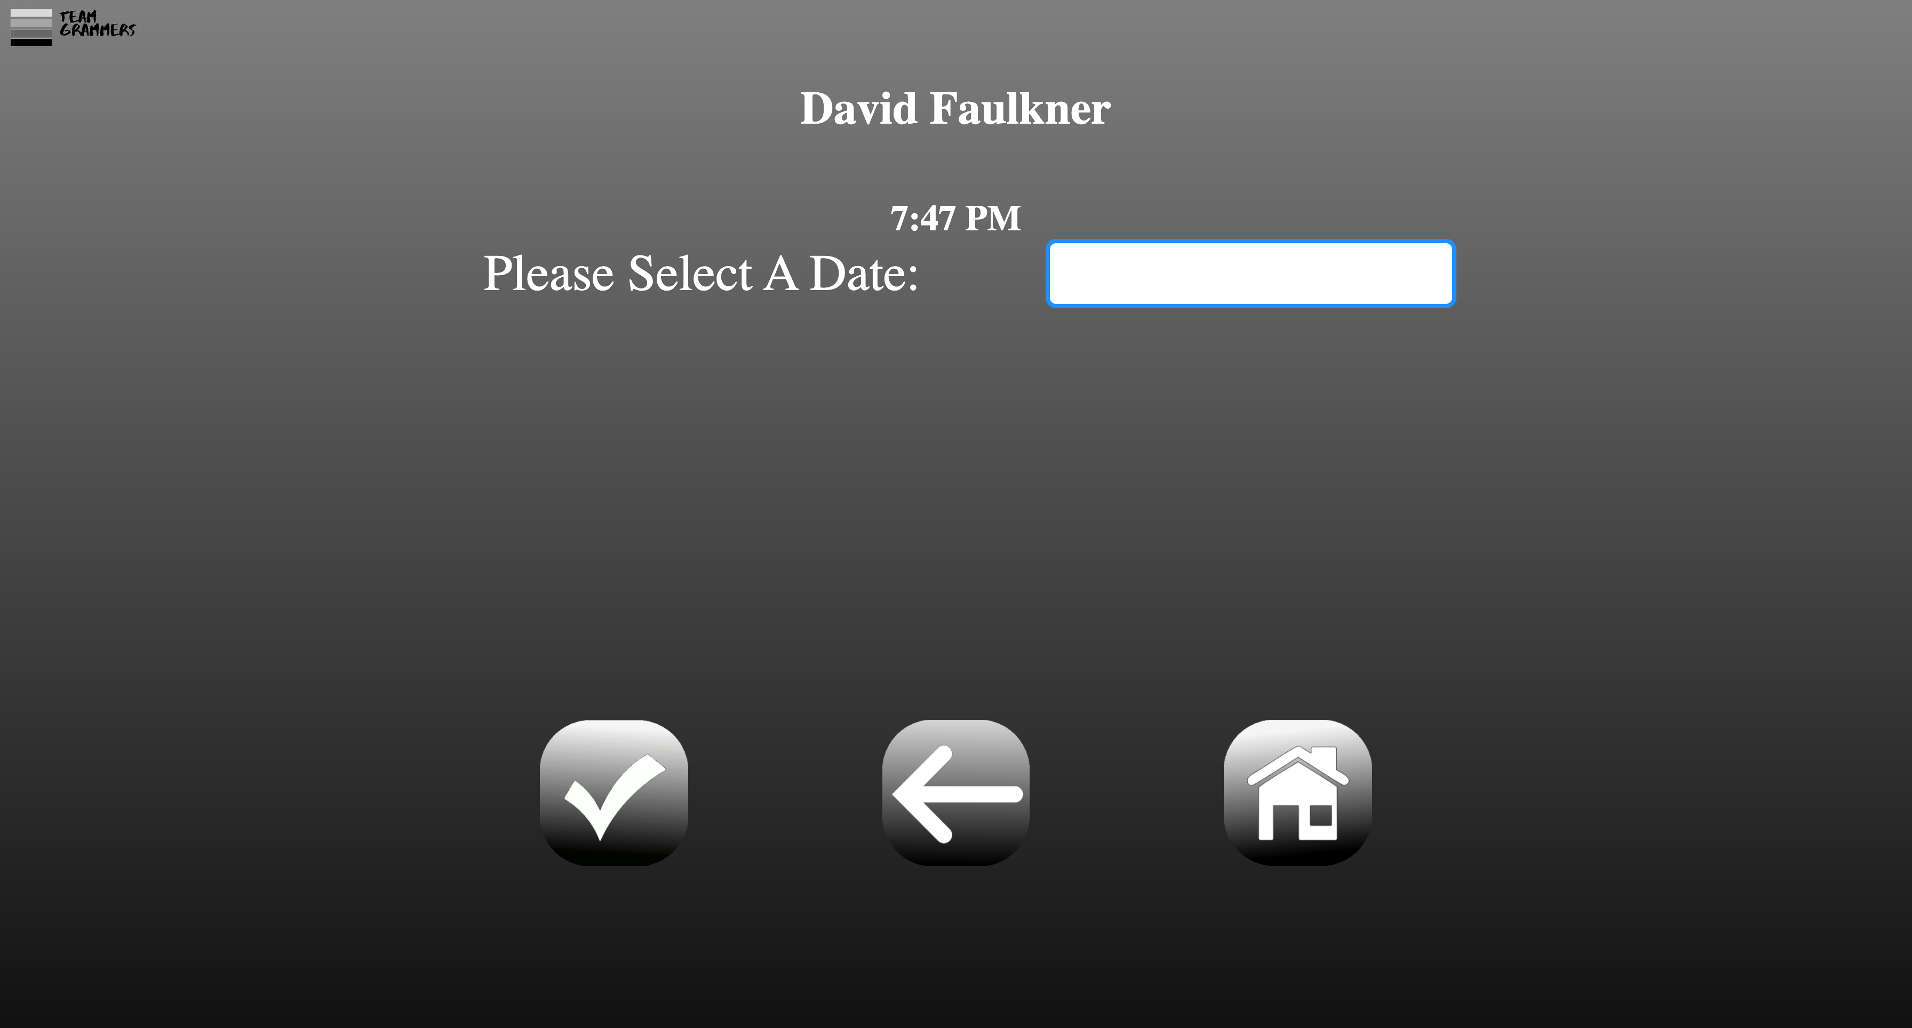

Where its says “Please Select A Date:” click on the fields and a calendar will pop up. Pick the desired date to view time logs then select the Checkmark icon. Select the “Back Arrow” to return to Welcome Screen or the “Home” Icon to logout.

The following screen will load upon submitting a date:

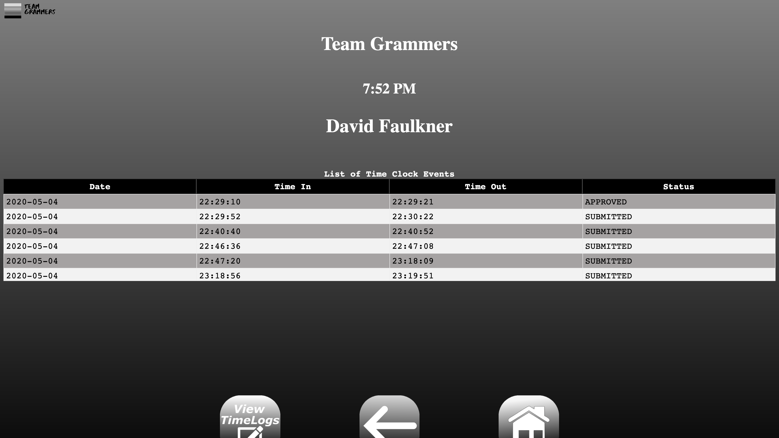

A table showing four columns (Date, Time In, Time Out, Status) will display. All Time clock events for that day will be displayed here. The user can see the status of the hours based on a manager input. Select the “Back Arrow” to return to Welcome Screen or the “Home” Icon to logout.

## Time Off View Screen

To see pending PTO, Sick or floater time, select the “Time Off” Icon at the Welcome Screen. This brings up the following page:

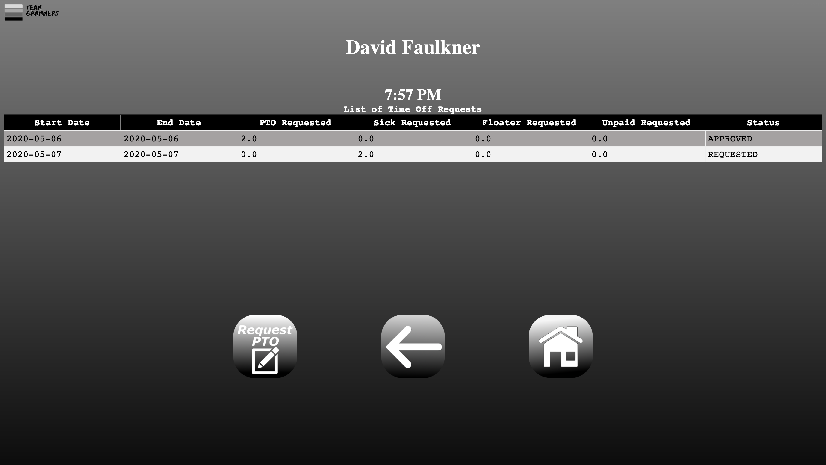

A table showing seven columns (Start Date, End Date, PTO Requested, Sick Requested, Floater Requested, Unpaid Requested, Status) will display. All pending Time Off requests are shown here. To create a new one, click the “Request PTO” Icon. Select the “Back Arrow” to return to Welcome Screen or the “Home” Icon to logout.

The following screen will show from selecting “Request PTO” icon:

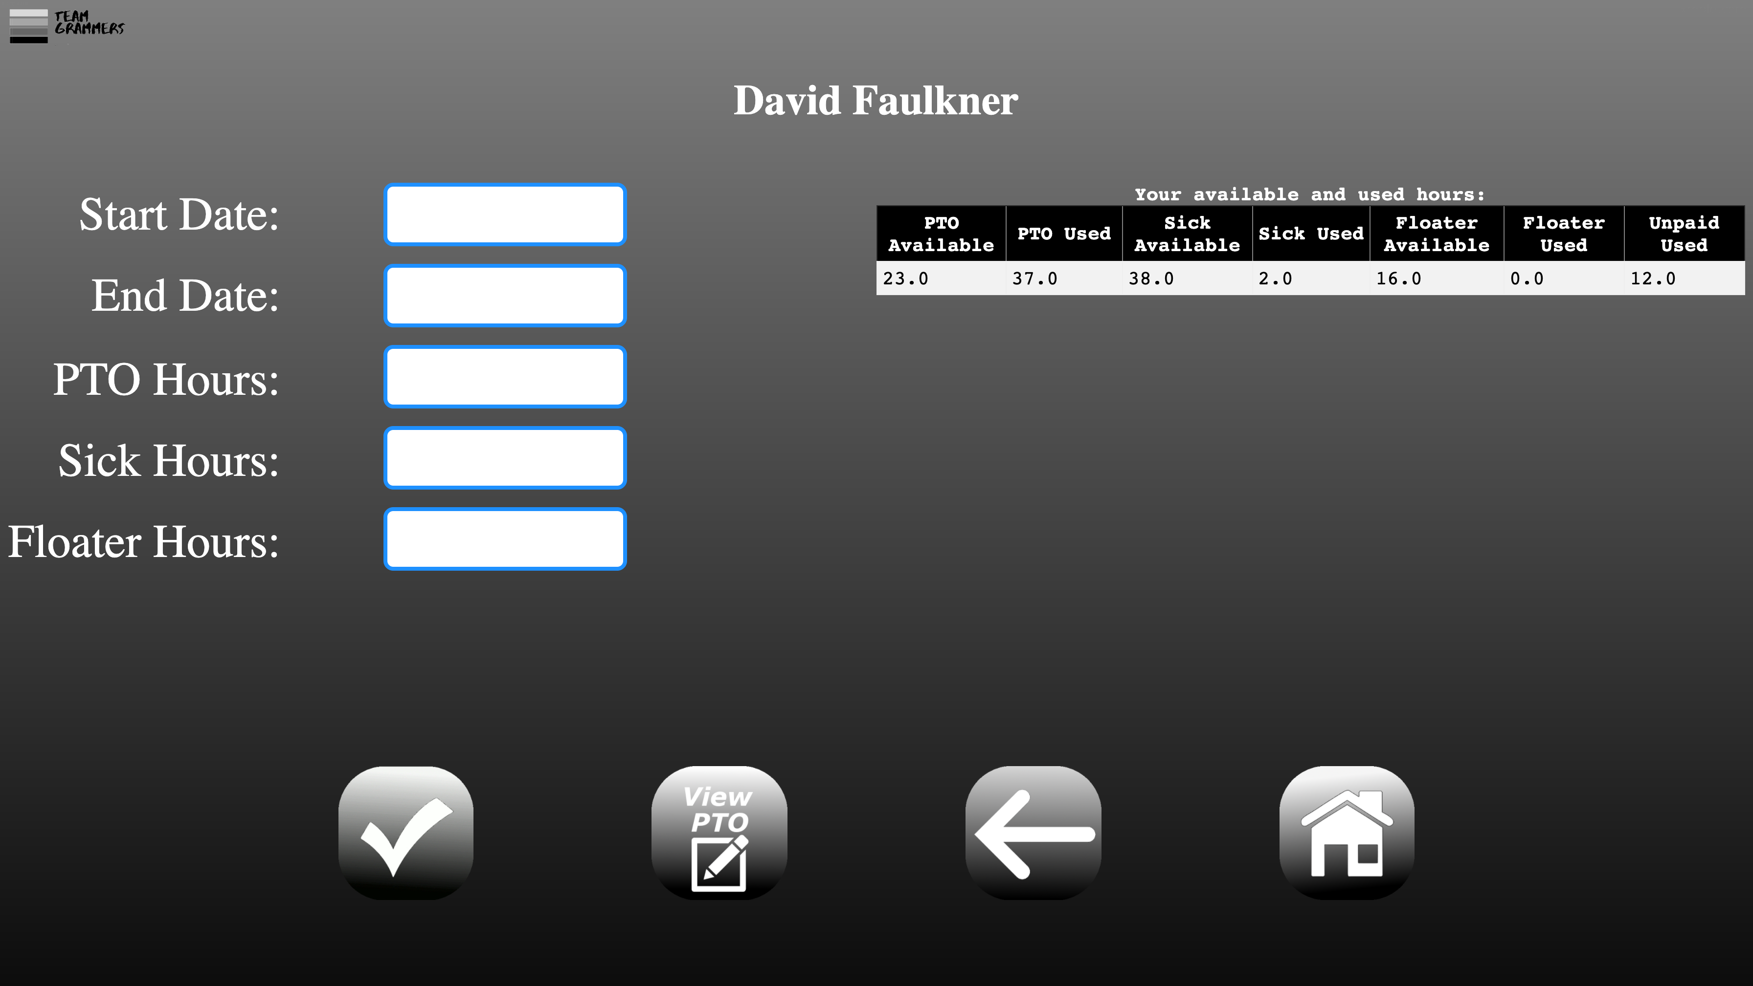

On the right a table showing seven columns (PTO Available, PTO Used, Sick Available, Sick Used, Floater Available, Floater Used, Unpaid Used) will display. On the left are a row of inputs for the user to make their request. Use the Start and End Date fields to pick the dates of needed time. Then the remaining fields are used to take the type and number of requested leave time. There is a limit of 8 total hours per day. Once filled out click the “Checkmark” icon to submit request. Select the “Back Arrow” to return to Welcome Screen or the “Home” Icon to logout.

Once submitted, the following screen will display:

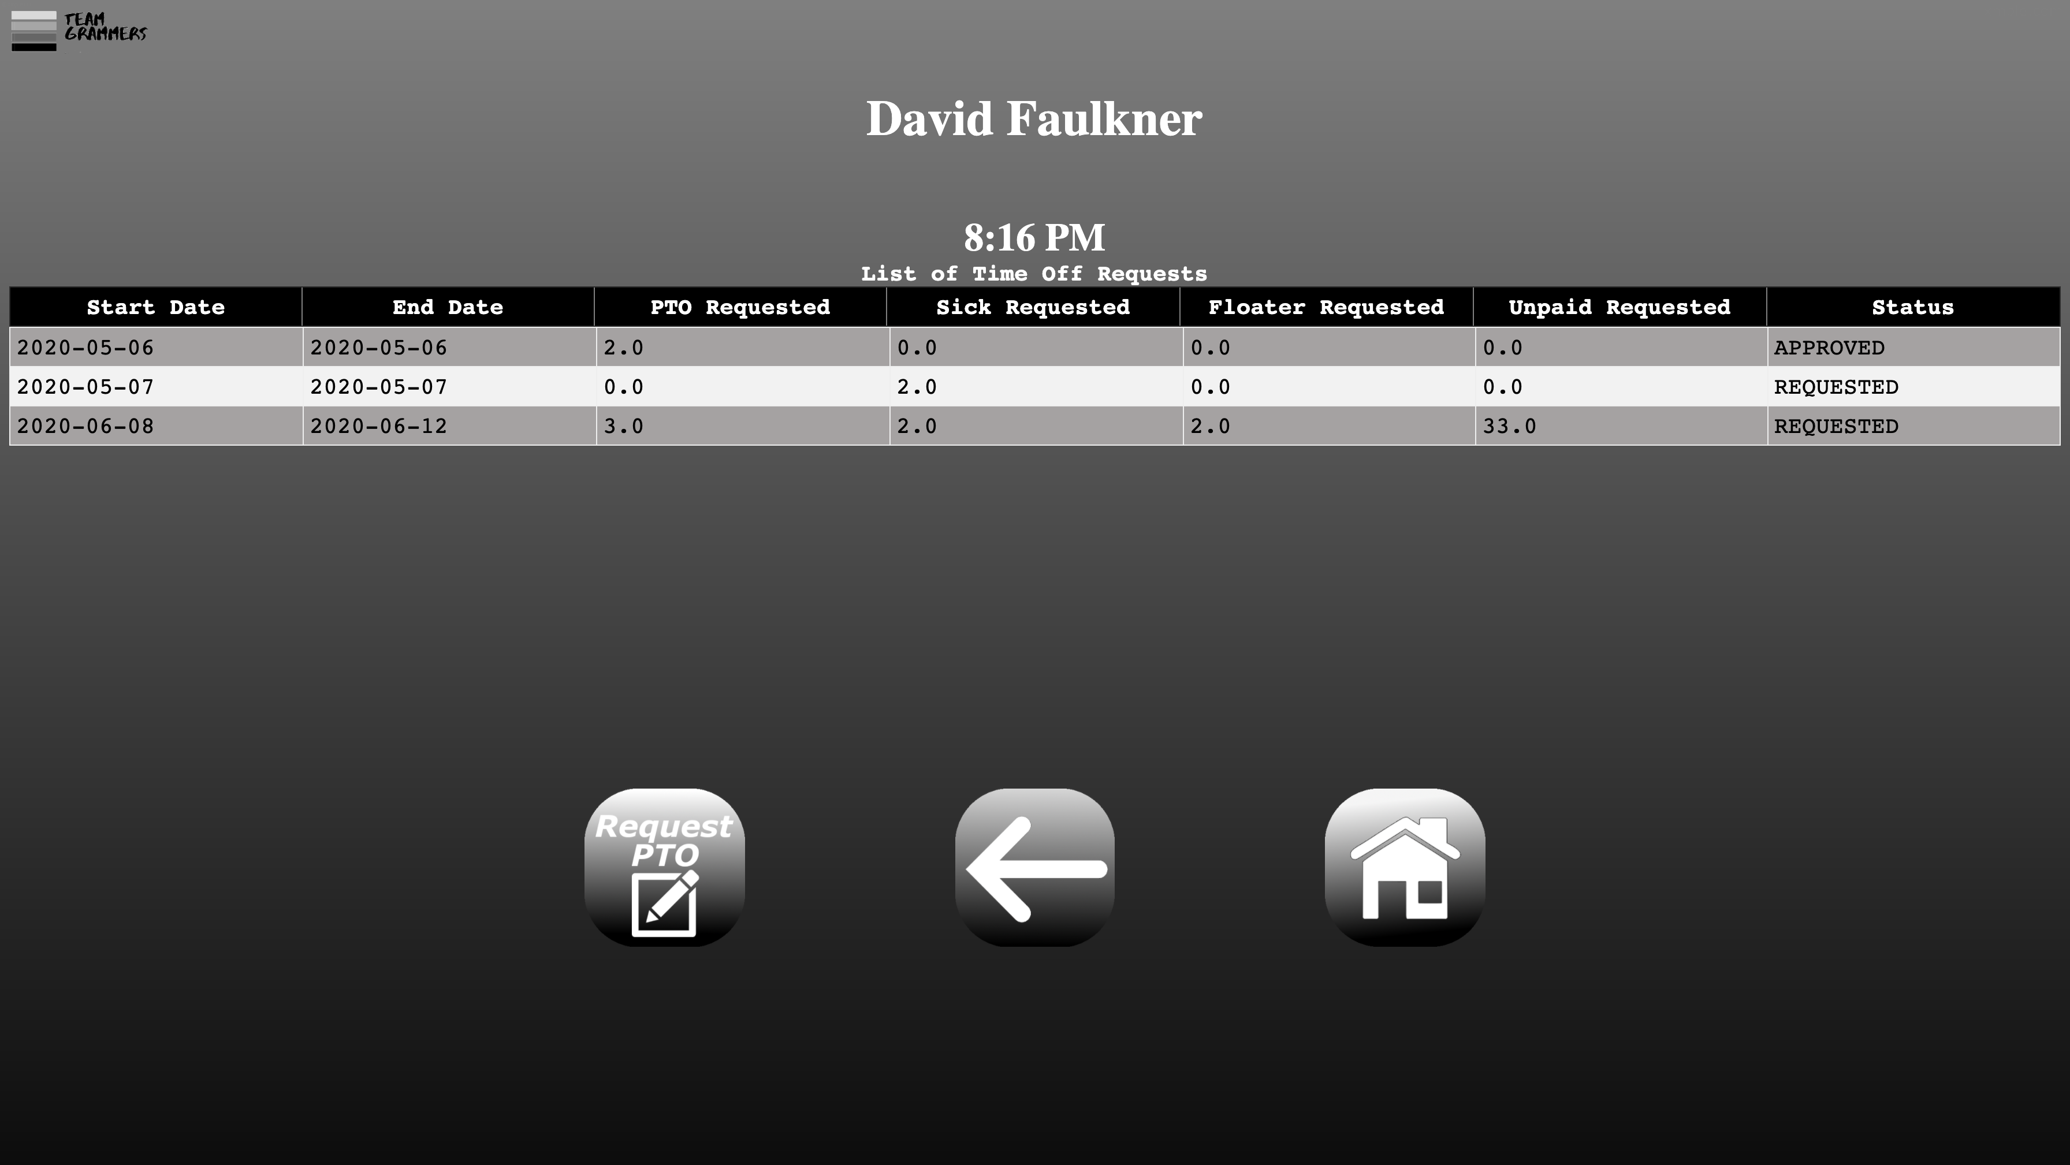

This is the previous screen with the now updated Time off request. A manager will determine the request.

# Manager Instructions:

## Open Application

To access application, click on provided icon link . You can also click [here](https://teamgrammers.azurewebsites.net/) to access the web app. This will open your default Internet Browser, which will than open the web app home page.

## Login Screen

The following screen will load in the default web browser:



It is here that you can login using your employee credentials, simply enter your ID and password.

When you are done click the checkmark icon to submit, or the X icon to clear the form.

## Manager Welcome Screen

Manager credentials bring up a different set of options. The following screen provides three options to the user:

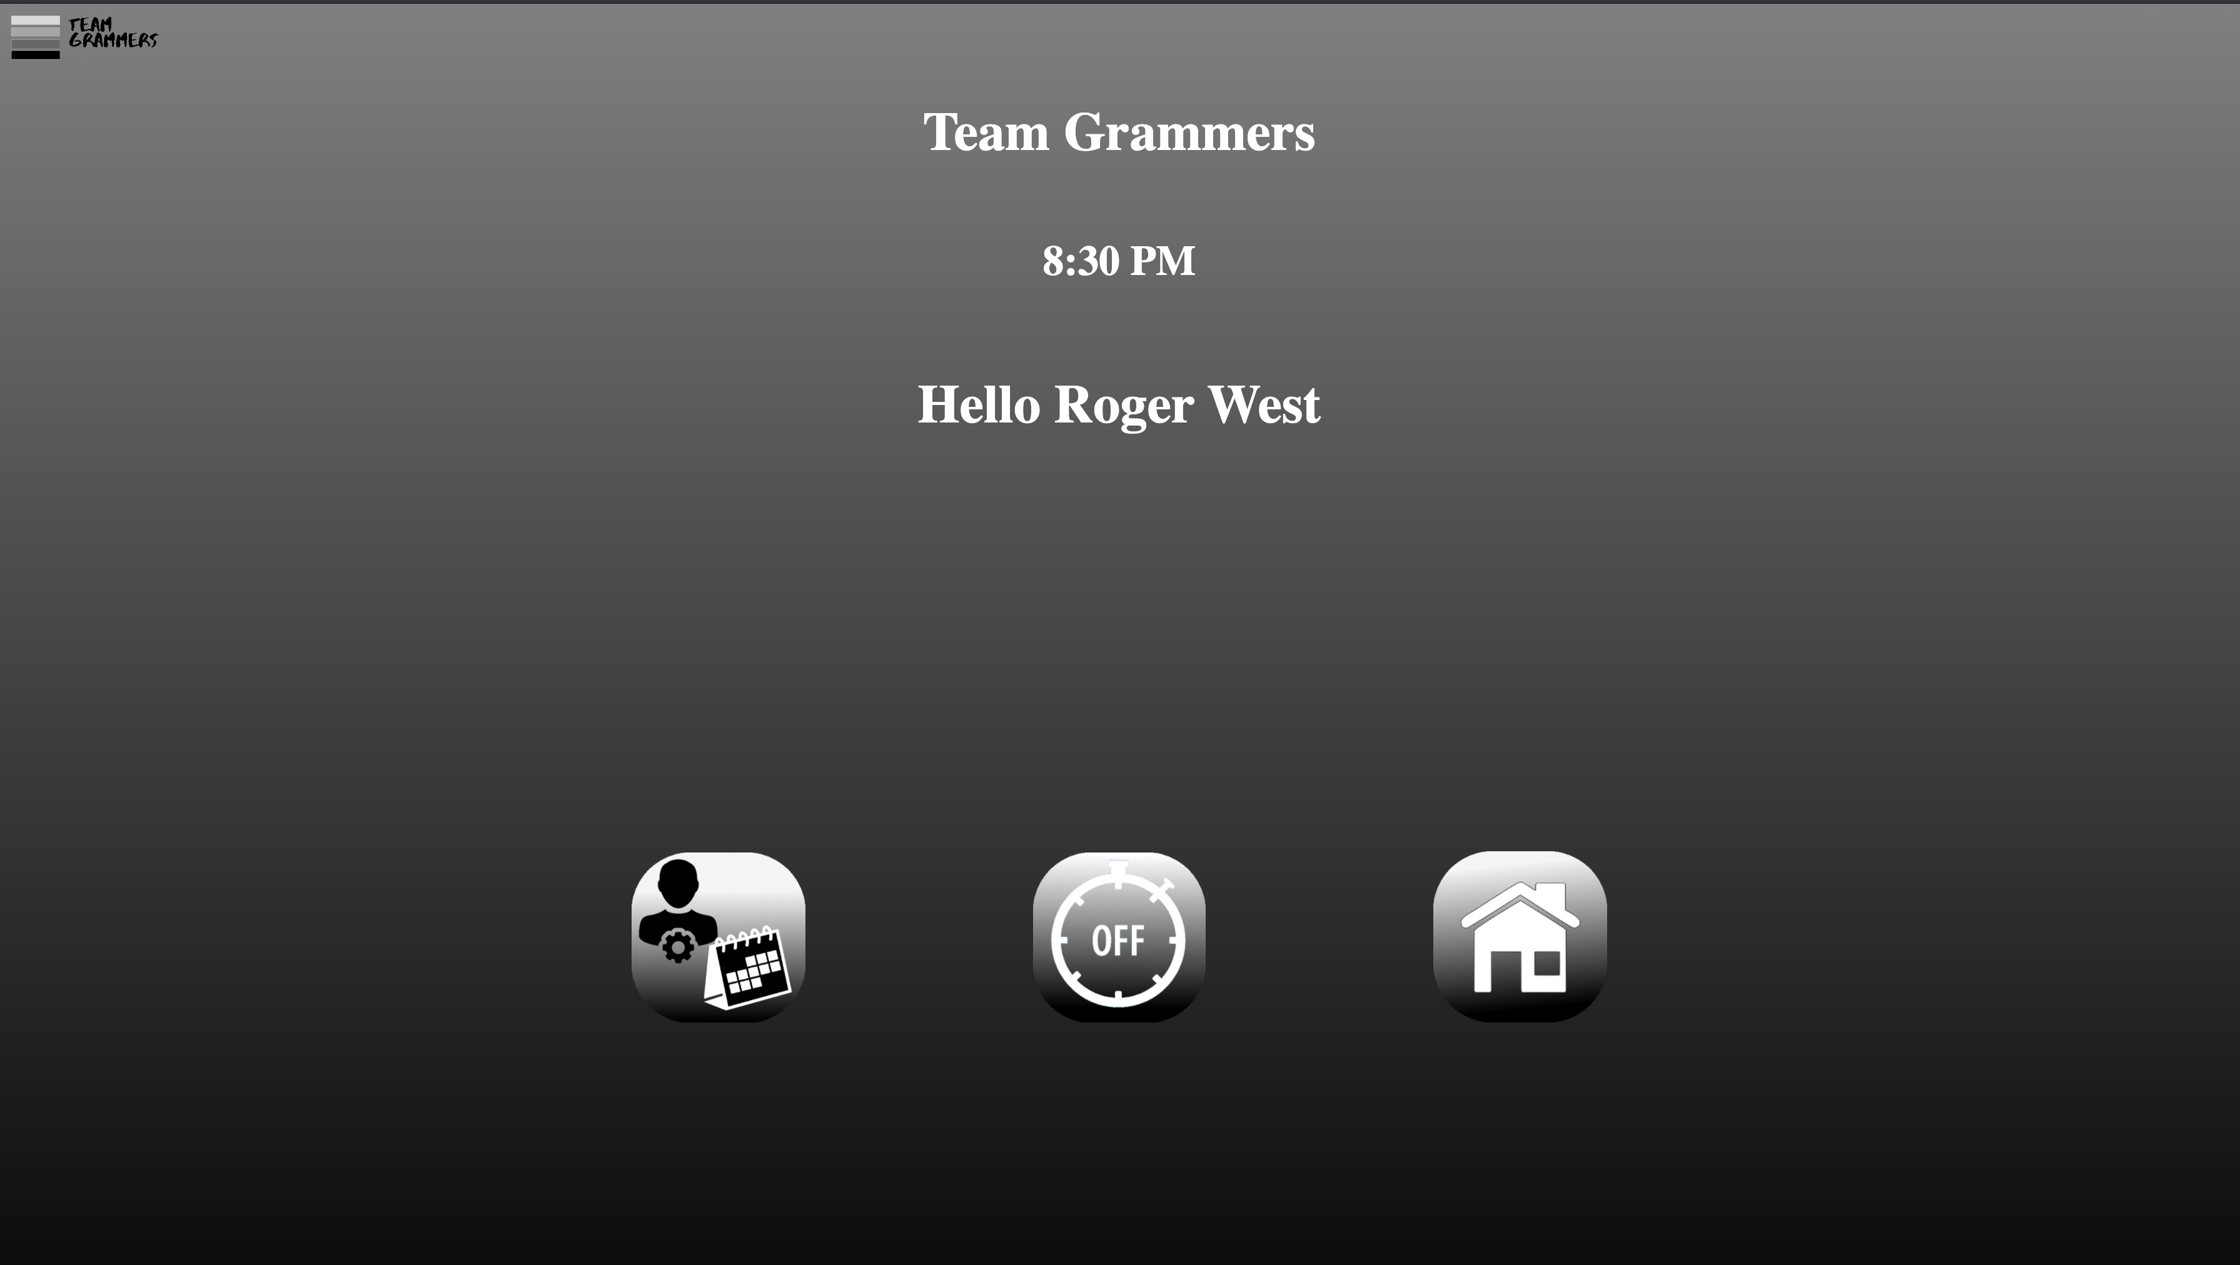

## Manager Time Clock Approval

When the “Approve Time Clock” Icon is selected the following screen will display:

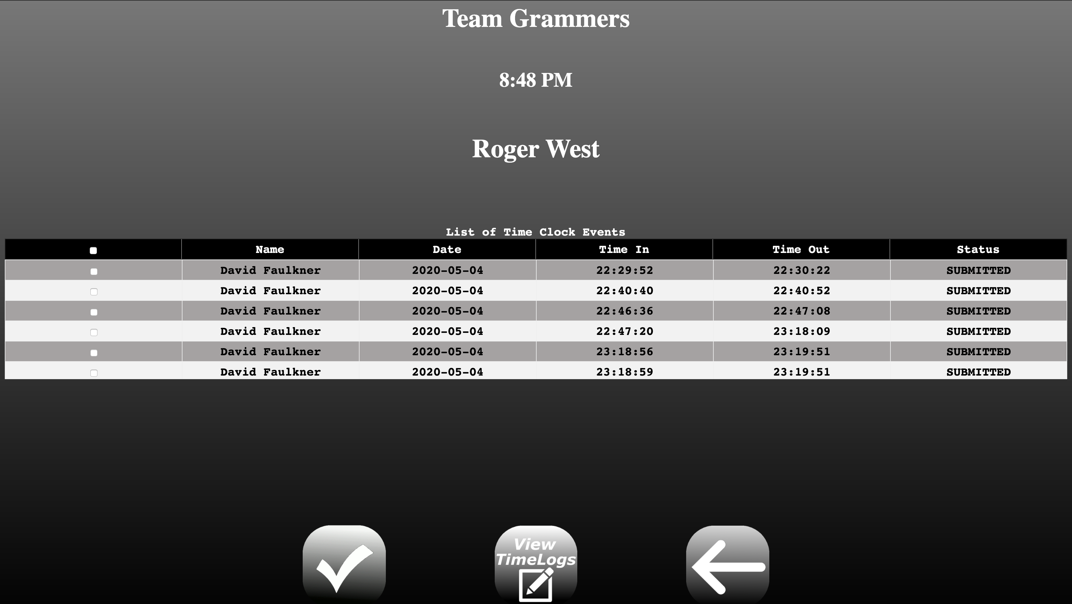

A table showing four columns (Date, Time In, Time Out, Status) will display. All Time clock events awaiting approval will be shown here. Each individual row can be selected or the top check box will check all of them. Upon selecting the desired logs, click the checkmark icon to submit the form. The following page will display:

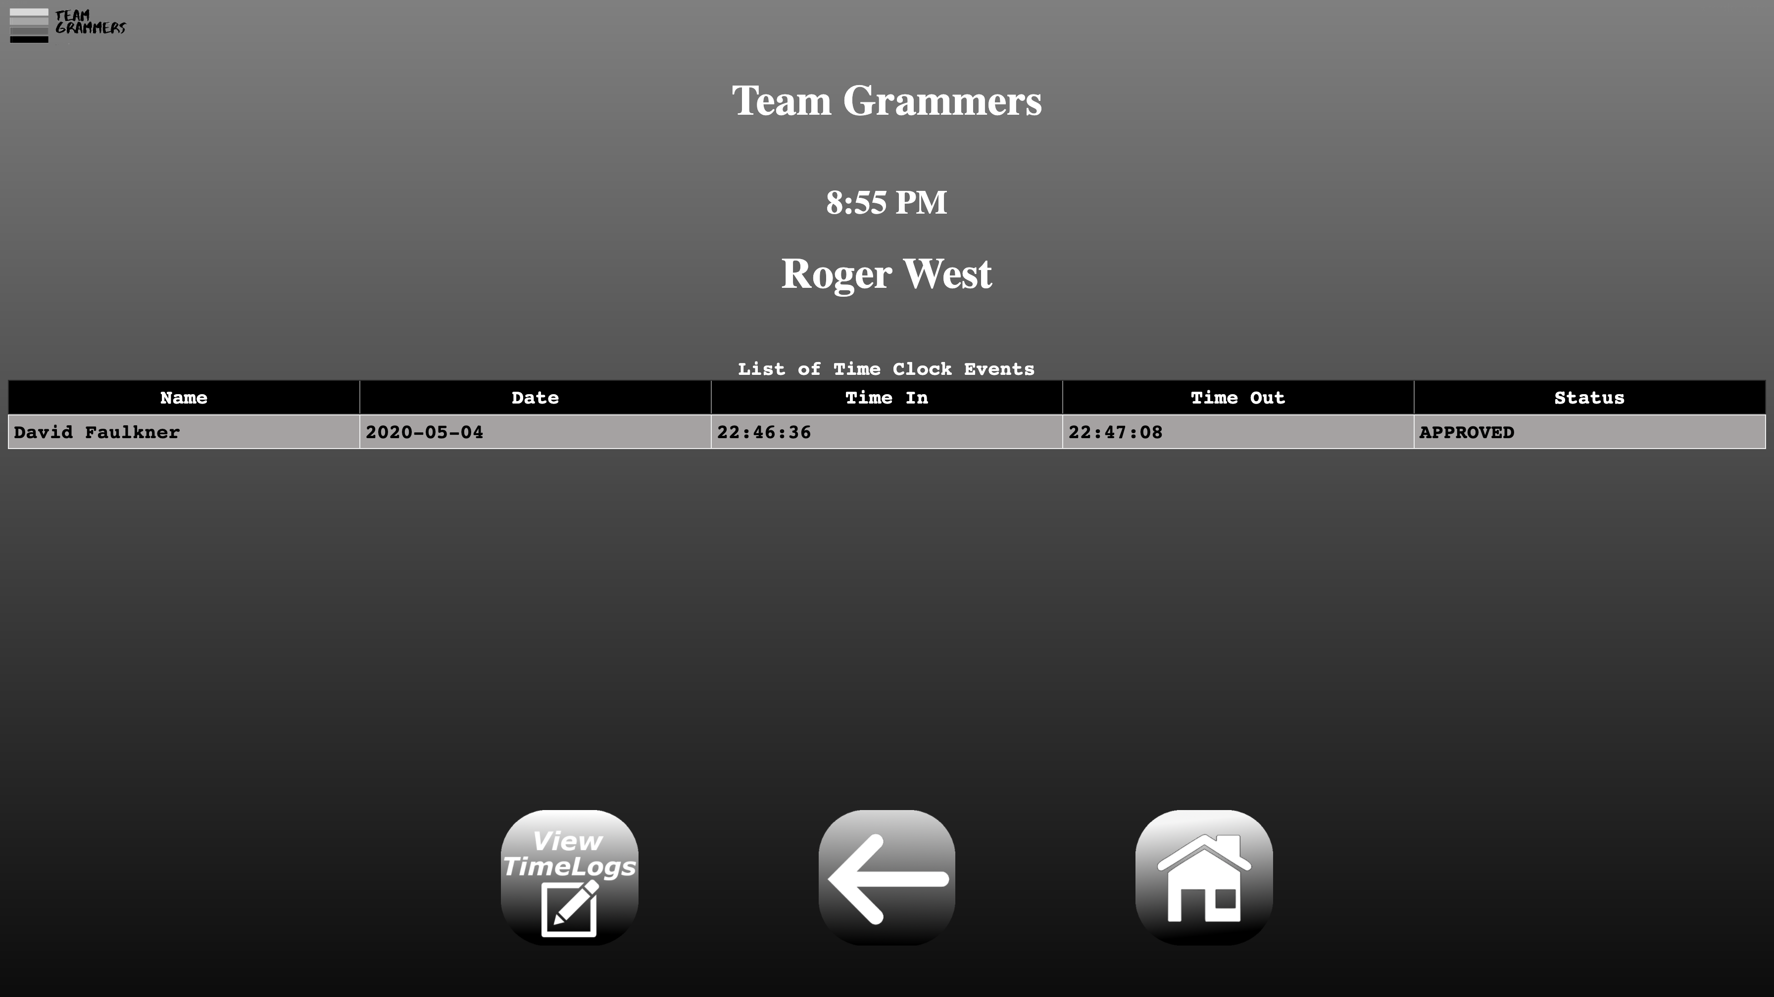

A table will show the approved time logs as proof of submission. The user will then have the option to either select the “ViewTimeLogs” Icon to view individual dates, select the “Back Arrow” to return to Welcome Screen or the “Home” icon to logout. Selecting the first will bring up the following page:

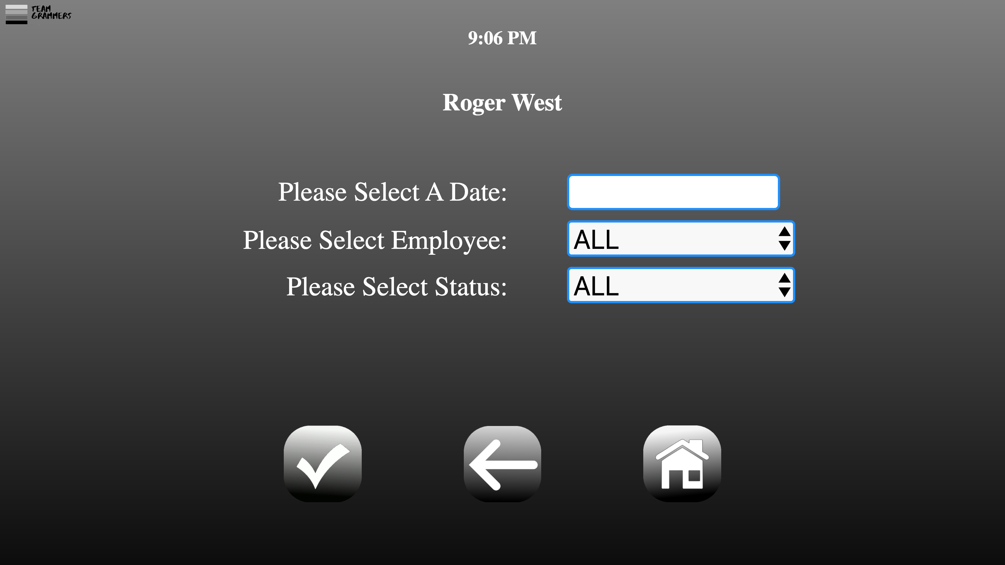

The first input field allows the user to select a date from a popup calendar. The second is to select the desire employee (or all) and the last is to filter out the status type if needed. Once all of the desired selections are filled out, the user can hit the “Checkmark” icon to submit the form. A table will printout the same as the previous one sowing the results. Select the “Back Arrow” to return to Welcome Screen or the “Home” icon to logout.

## Manager Timeoff Approval

Selecting the “Manager Time Off” icon will bring up the following page:

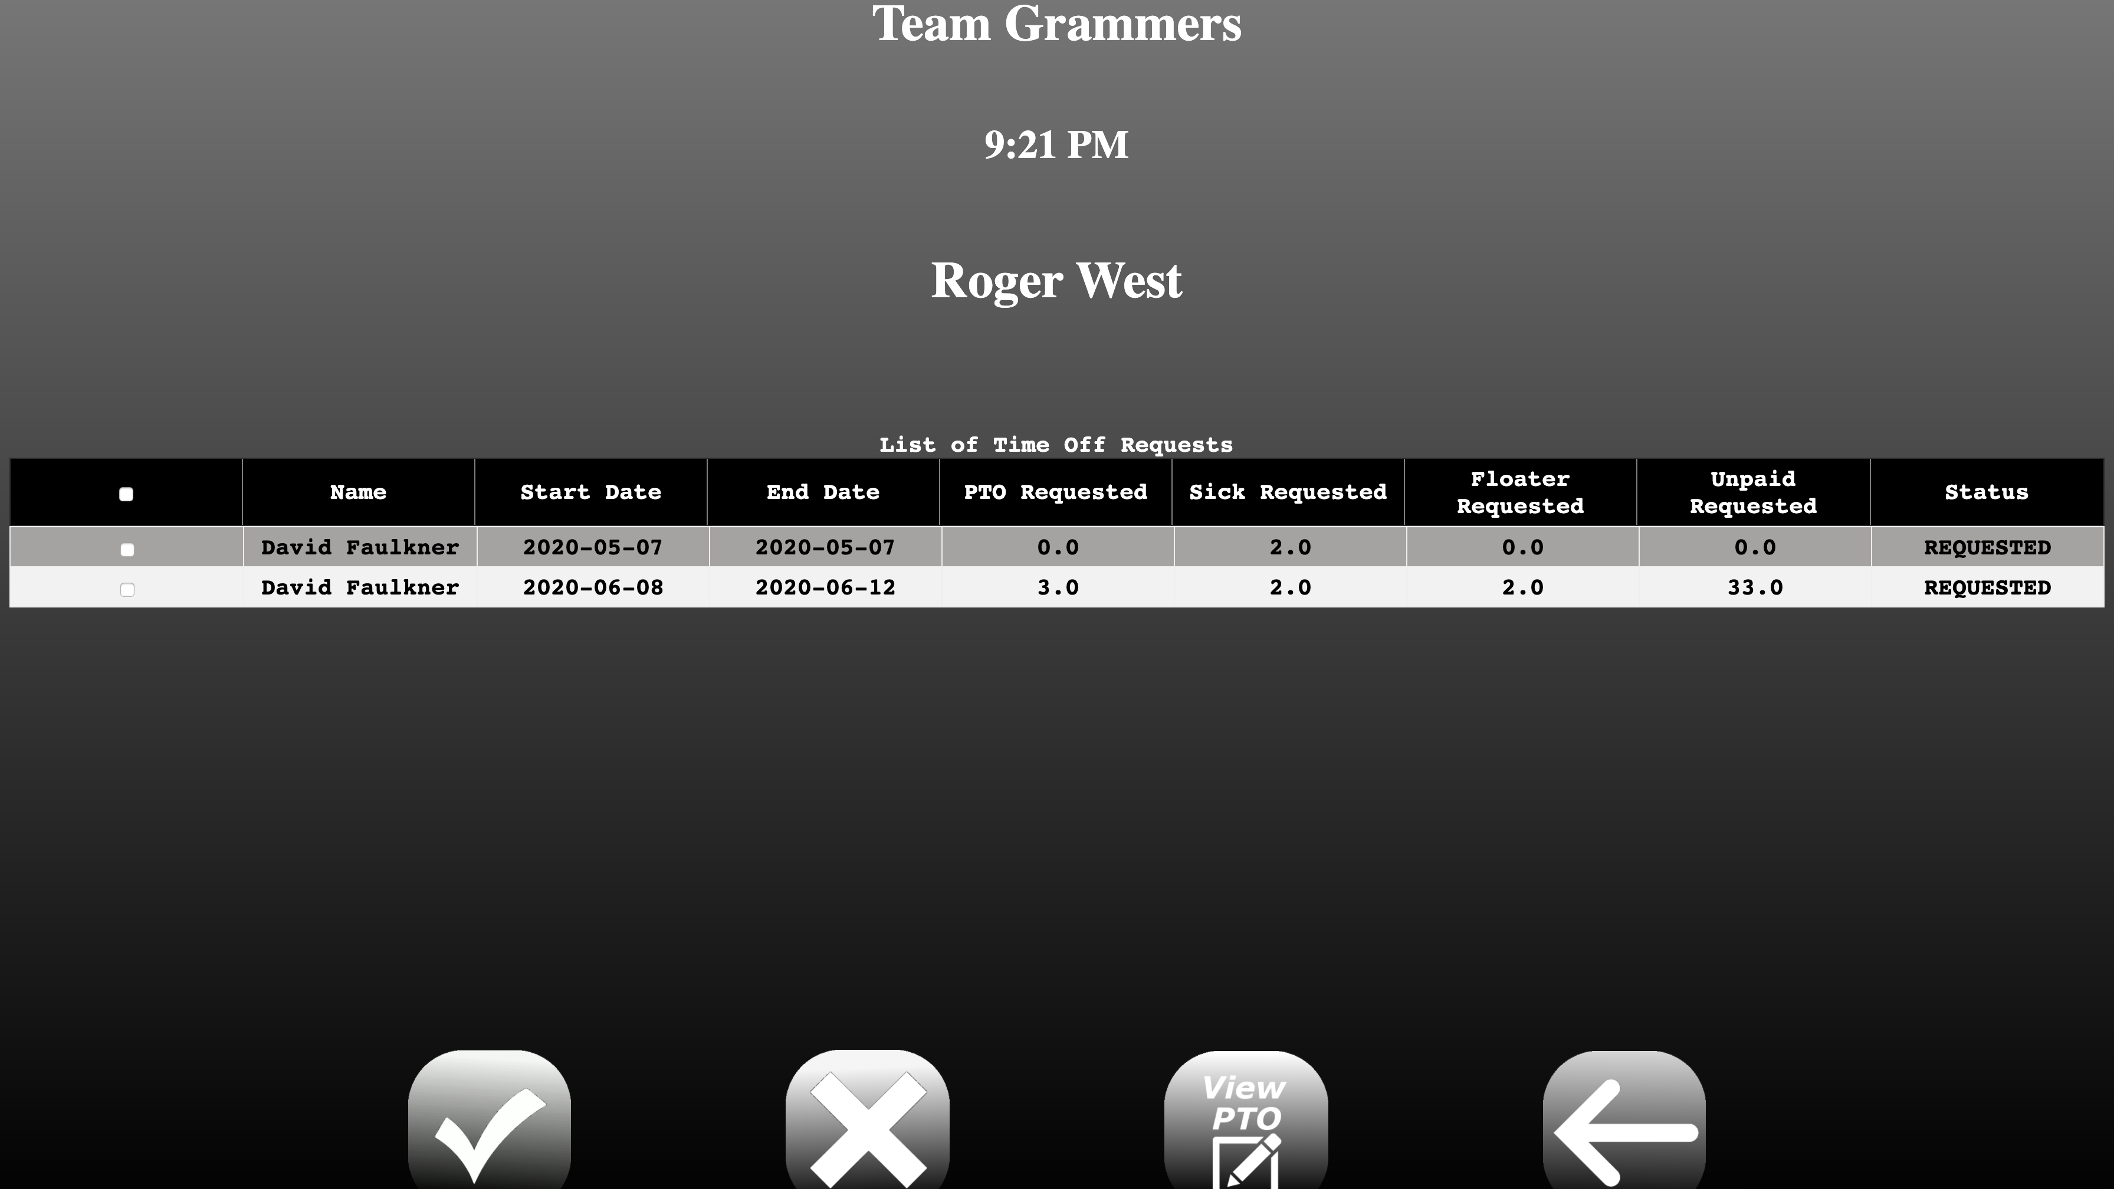

A table showing eight columns (Name, PTO Available, PTO Used, Sick Available, Sick Used, Floater Available, Floater Used, Unpaid Used) will display. Each individual row can be selected or the top check box will check all of them. Upon selecting the desired Time off requests, click the checkmark icon to submit the form. This will approve the request, or to deny it select the X icon. The following page will display:

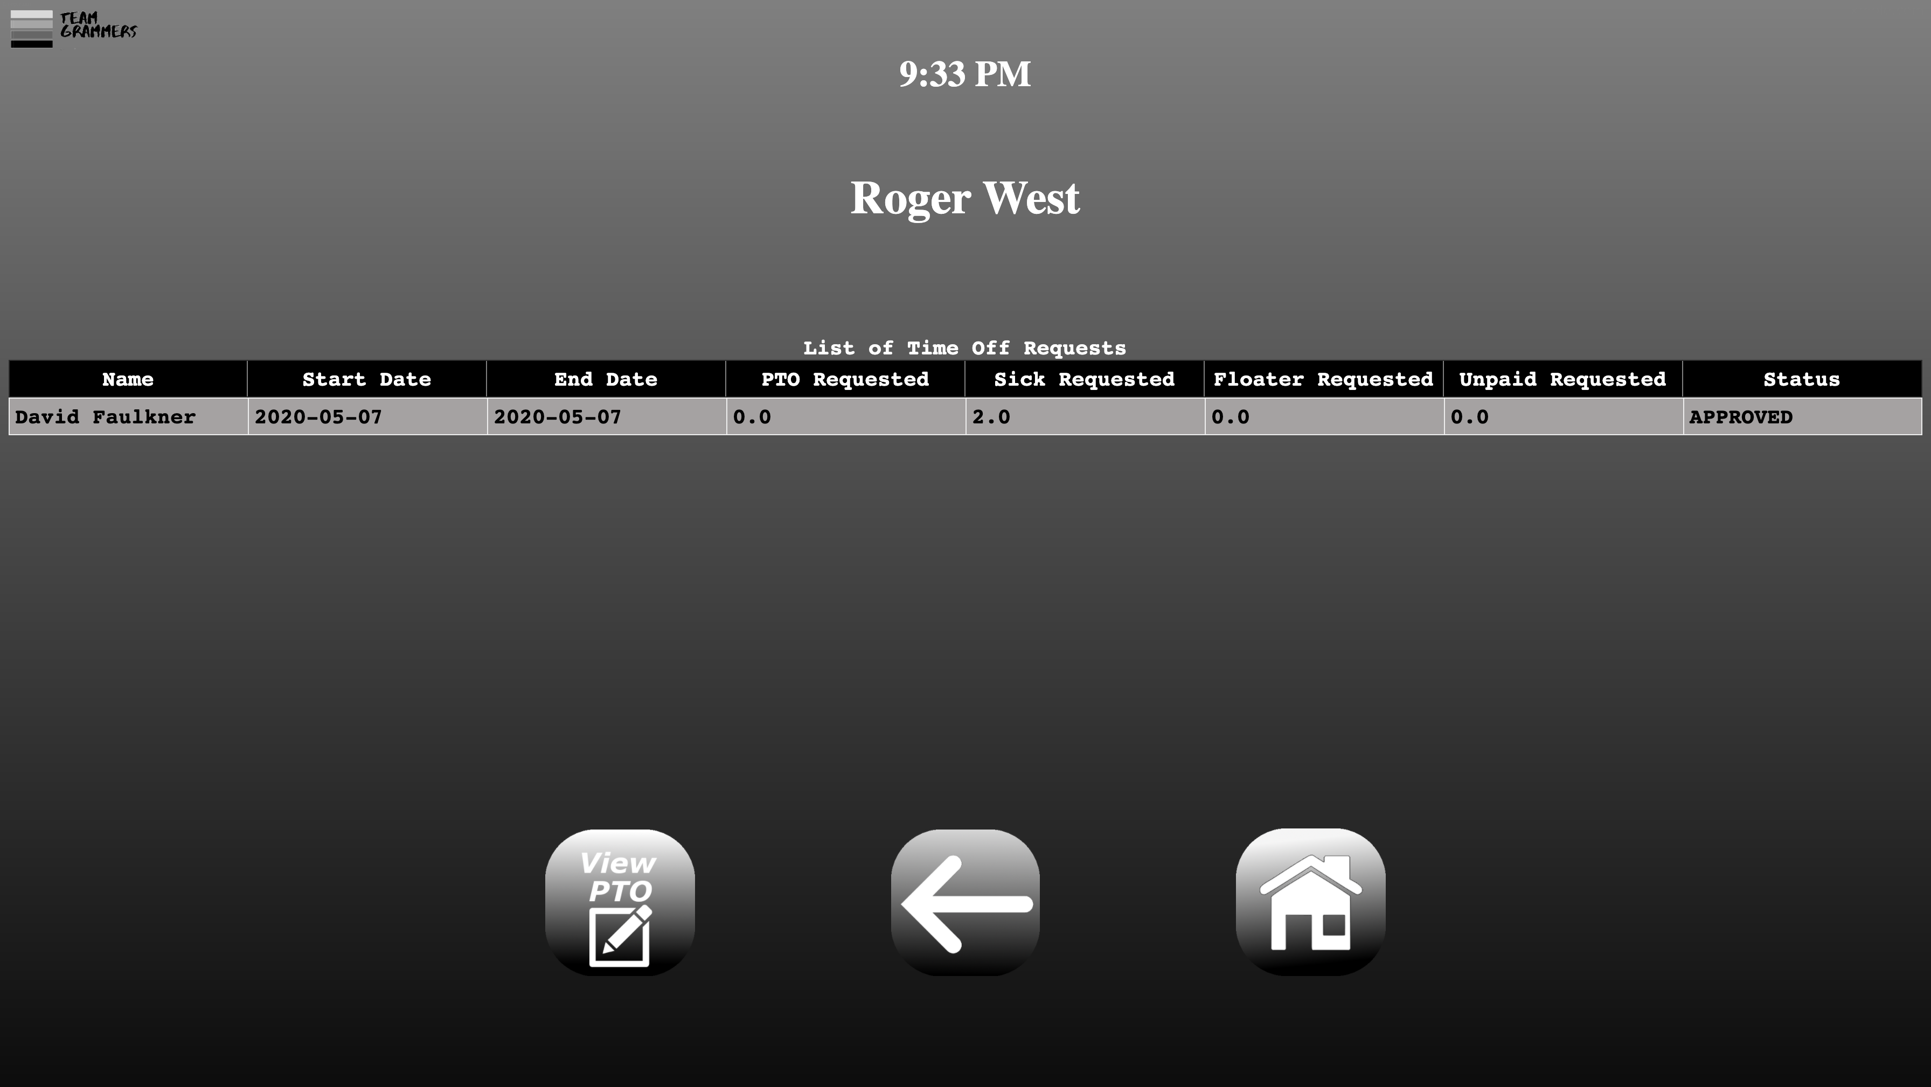

A table will show the approved time logs as proof of submission. The user will then have the option to either select the “ViewPTO” Icon to view individual dates, select the “Back Arrow” to return to Welcome Screen or the “Home” icon to logout. Selecting the first will bring up the following page:

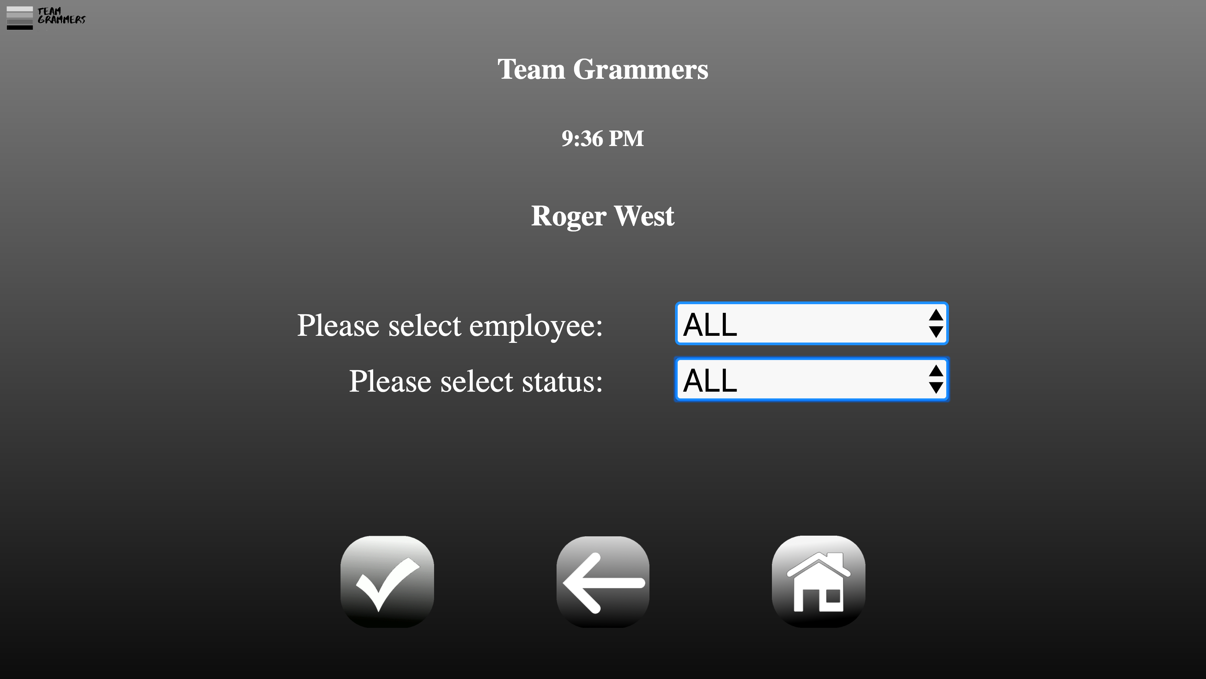

This page will allow the user to filter out the Time off requests by employee and the status of the request. Once filled to submit the form select the Checkmark icon and it will bring up the following page:

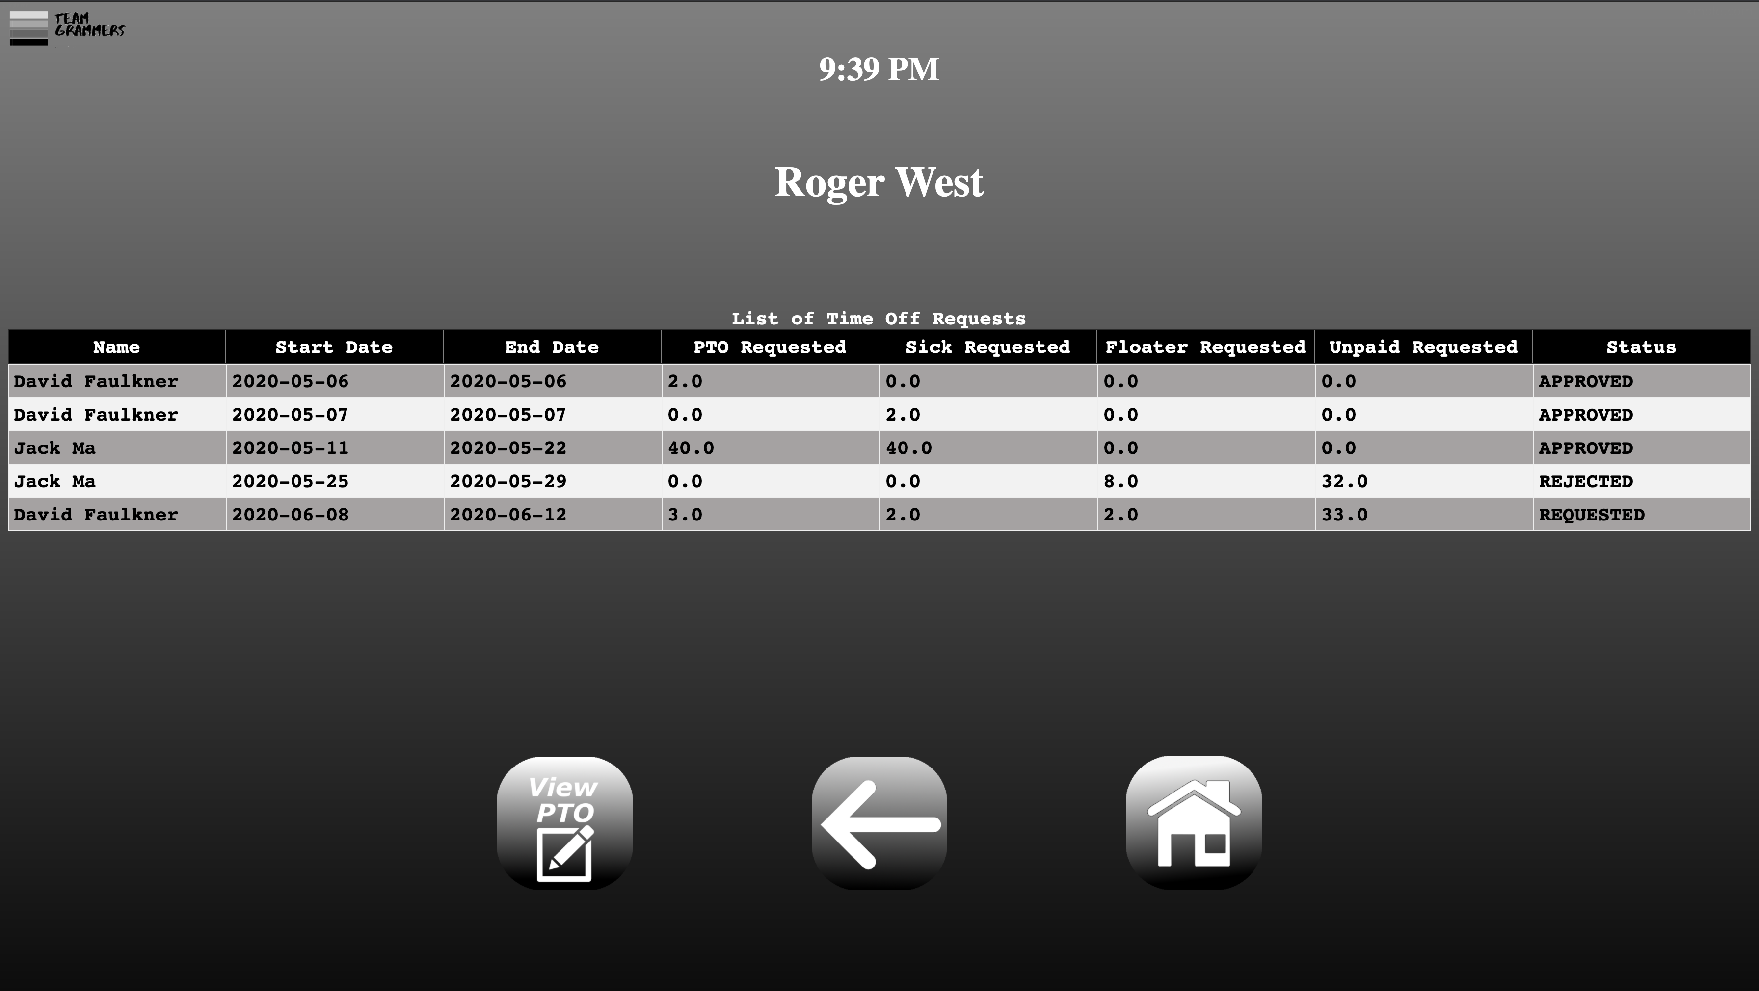

A table showing eight columns (Name, PTO Available, PTO Used, Sick Available, Sick Used, Floater Available, Floater Used, Unpaid Used) will display. It will be the filtered results of the previous selection. The user will then have the option to either select the “ViewPTO” Icon to view more individual dates, select the “Back Arrow” to return to Welcome Screen or the “Home” icon to logout.